Intelligent Systems

20-EECE-5136

Homework 1

Due Tuesday, October 3rd, 2017 A. D.

By Tomas Seymour

M05873855

**Problem 1**

Problem Summary:

A mathematical model is given in a MATLAB script. Implement the given mathematical Izhikevich model for neuron behavior in the ways specified. There is a variable *I* which represents an external current input to the neuron system. The more that the system receives input, the faster the “neuron” will charge and produce a spike. This in turn, will increase the amount of times the neuron will spike over a given time which for this experiment is 500 steps of 0.25. The system will begin receiving input only after the first 200 steps completed.

Increase the amount of external current input by increments of 0.25mA and record observations about how often the system fires off a spike based on *mean spike rate, R.* The mean spike rate is the number of spikes produced in the remaining 300 steps divided by 300. Make a plot comparing *R* to *I.*

Make additional plots comparing the actual voltage signal against time for *I* = 1, 5, 10, 15, 20 separately.

Results:

Here is a MATLAB plot comparing the mean spike rate against increasing external input:

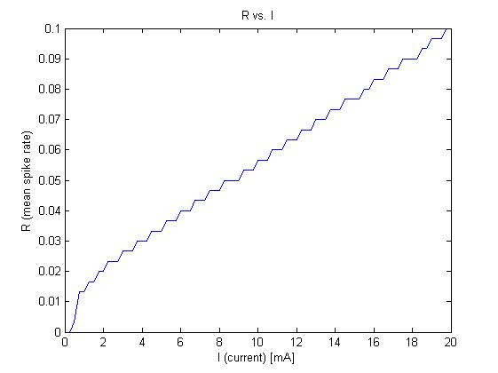

*Figure 1.*

Here are the MATLAB plots for the individual 500-step time-series behavior for different external inputs:

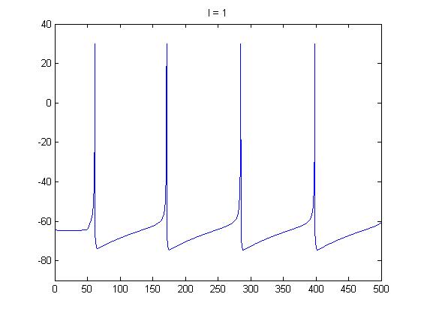

*Figure 2: The action potential plot vs. time for the neuron when the external input current is 1.*

**Problem 1**

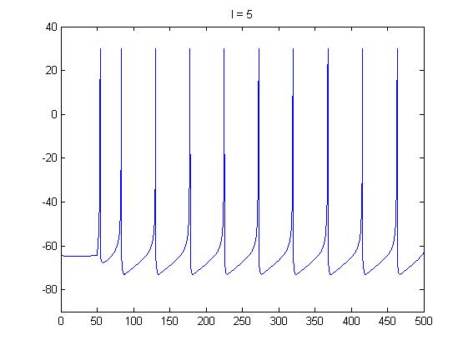

*Figure 3. The action potential plot for the neuron when input is 5.*

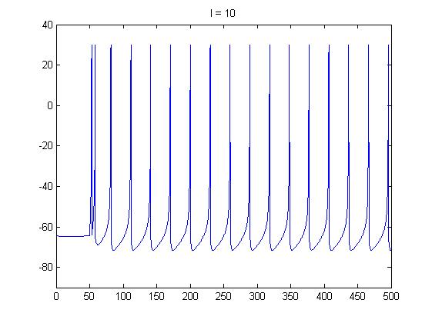

*Figure 4: Input is 10.*

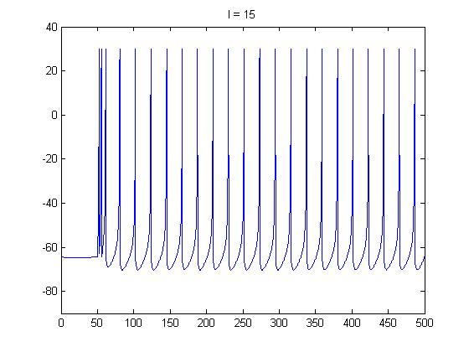

*Figure 5: The action potential plot when current is 15.*

**Problem 1**

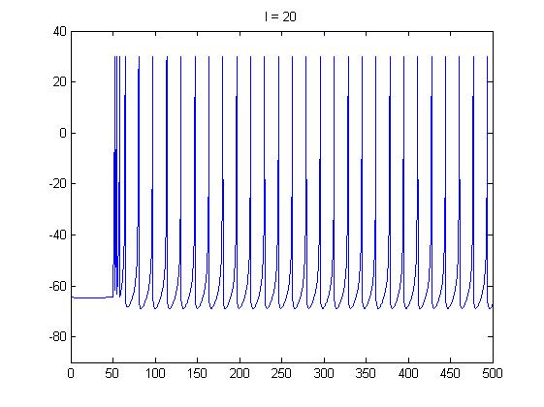

*Figure 6: Input is 20.*

Discussion:

The frequency of spikes seems to increase linearly with respect to the steadily increasing input current as one can see plainly from the *Figure 1* plot. When the current is small, less than 0.3mA, there is no spiking behavior seen.

Interesting to note that the model seems to simulate rebound effect just as when the neuron begins to fire the around time = 50. The neuron system doesn’t immediately go to a steady rhythm of spikes. Instead, depending on how high the current input is, there is the possibility for a clustering of spikes to occur at the beginning of the signal reception, due to little or no refractive period.

Conclusion:

The model suggests to simulate the neuron firing accurate to the real life action potential behavior in neuron cells. Additionally, it is a simple model designed to implement simple neuron networks and beneficial to study at the action potential level what happens. Action potentials from neurons can trigger post-synaptic potentials at synapses in another kind of function, and modifications can be made to integrate these charges as external input current to a receiving neuron as we can later see in problem 2.

**Problem 2**

Problem Summary:

Now, implement a neural network with three neurons using the same math model as Problem 1. Neurons A and B feed their axons into the cell body of neuron C via synapse. When either A or B fire into C, neuron C will interpret a firing as conductive of post-synaptic potentials which will feed C’s external input current. Each synapse will have a weight *wA* and *wB* respectively.

The external input is represented in formula as:

*IC(t) = wA yA(t) + wB yB(t)*

The functions *yA* and *yB* will become 1.0 respective to whether that neuron just reached an action potential of 30 indicating that it had just fired. At any other time, they will be 0, yielding nothing to the current.

The weights of both synapses are set to 100.0 and the external input to the neuron B is fixed to 5mA. Then, *IA* will be steadily increased as the neuron was in Problem 1. Then, make plots and inferences about mean spike rates at the different neurons.

Results:

Plots:

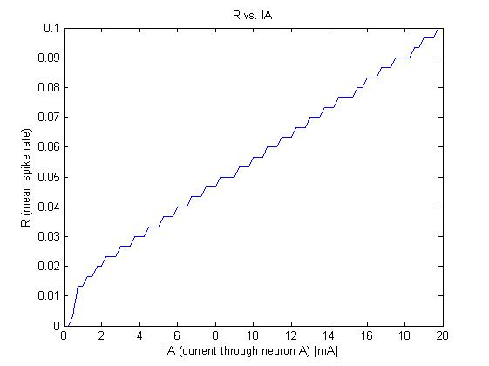

*Figure 7: This is a graph of the mean spike rate vs. the external input to neuron A. This is the same exact behavior shown in Figure 1.*

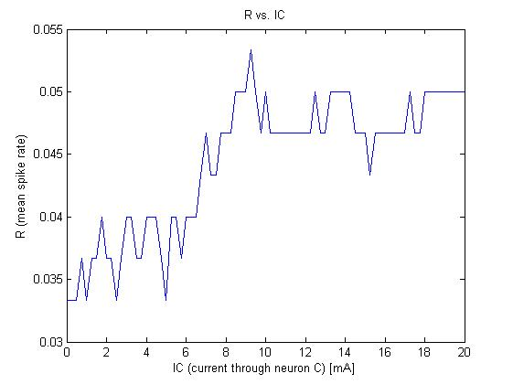

*Figure 8: This is the figure for the receiving neuron C, which is fed current only whenever there is a spike in neuron A, B or both.*

**Problem 2**

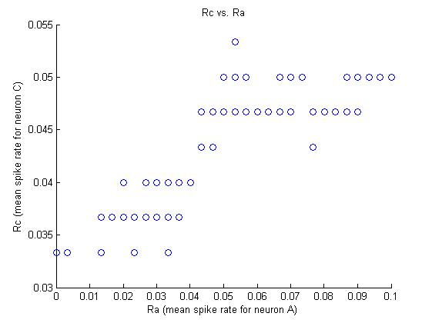

*Figure 9: This is a scatter plot for comparing the mean spike rates between the neurons A and C. There is apparent positive correlation and interesting plateau shapes in the data. But there is other things going on also with how the firing signals from A and B contribute to C.*

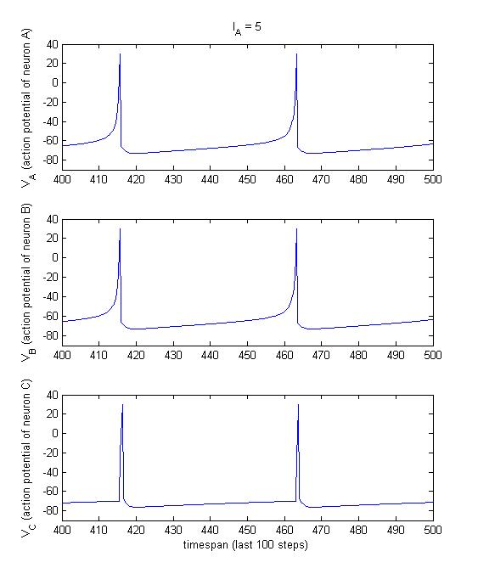

*Figure 10: Action potentials are compared between all three neurons over the last 100 steps in time when IA is 5. Note that because IB is also 5, they both contribute to the input current to neuron C whenever they fire off one spike, resulting in sharp spikes in neuron C.*

**Problem 2**

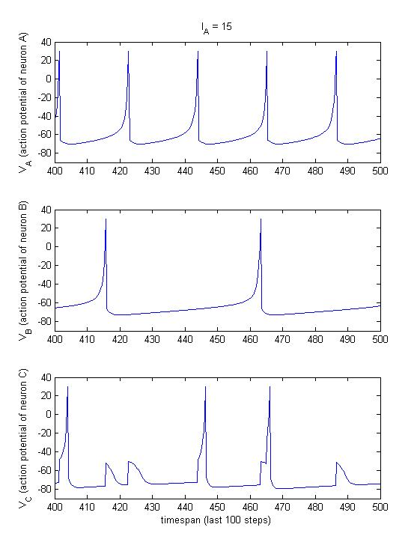

*Figure 11: Action potentials are compared when IA is 15 and IB remains 5.*

Discussion:

It goes without saying that the plot in Figure 7 would be unchanged from the one in Problem 1. They are the same behavior because it is the same external inputs with the same neuron constants in the model.

Figure 8 is more interesting because of the apparently odd behavior shown by neuron 3. On average, the frequency of spiking in neuron C is much lower than that in the behavior shown in neuron A for the same increasing input signal.

When we look at Figure 9, and begin to analyze how neuron A affects neuron C, patterns begin to emerge. It isn’t too obvious but it can be interpreted that the mean spike rates in neuron C go up and down in some strange oscillatory pattern as the frequency of spikes in A increase.

Figures 10 and 11 give us a clear understanding on how this model works now with the three neurons. When A and B fire off close to one another temporally speaking, as shown in the Figure 10, when the external input currents they both receive are the same, they both contribute to the input current to neuron C which sets off its own spike. When A and B are the same, then C will also look very similar to them both. There is a slight difference in how signal C looks. This is because A and B both receive continuous input signal while C will only receive it for a very short amount of time. However, the synaptic weights make sure that neuron C will charge completely and fire.

Conclusion:

The phase of the signal frequencies in the pre-synaptic neurons A and B seems to contribute the most to the production of spikes in the post-synaptic neuron C. However, the phase doesn’t have to be precise, if the neurons spikes are close enough together in time, then spiking seems to occur anyway. Which seems to go against the understanding that firing in C can only happen when both A and B fire off at the same time as given in the MATLAB script for this model.

**Problem 3**

Problem Summary:

Use the same model as in Problem 2 but while fixing the external input currents *IA* to 5 and *IB* to 15 and the synaptic weight *wB* to 50. Then, the other weight *wA* is set as the variable. It is steadily increased from 50 to 200 in steps of 10. Make plots and observations.

Results:

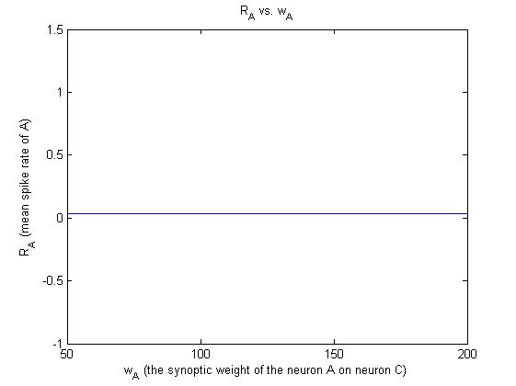

*Figure 12: plotting the varied synaptic weight against the mean spike rate of A. It’s a flat function. RA is 0.0333 constantly.*

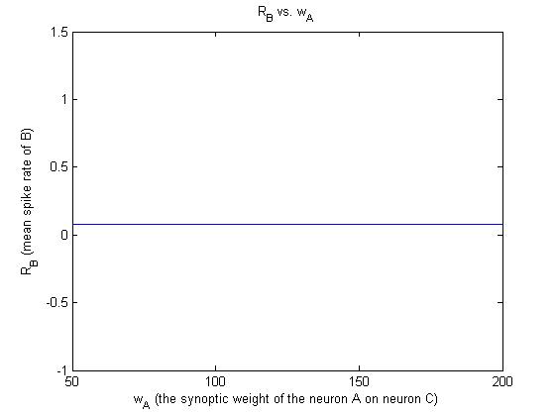

*Figure 13: plotting the synaptic weight against the mean spike rate of B. It’s a flat function. RB is 0.0767 constantly.*

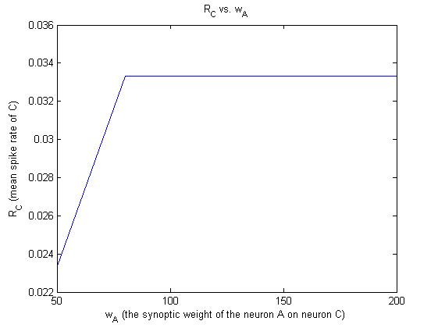

*Figure 14: plotting the synaptic weight against the mean spike rate of C. It begins at 0.0233 then rises to 0.0333 when wA is greater than 80.*

**Problem 3**

Discussion:

I think it is evident that the synoptic weight of the neuron A on C won’t have any effect on how either neuron A or B function, given that Figure 12 and Figure 13 show constant values. The weight is only applicable at the input of neuron C where the spikes contribute to this integration.

The weight does influence the mean spike rate of neuron C.

Conclusion:

My explanation of what this pattern we observe in the plots is that whenever the weight that neuron A has on neuron C is less than 80, when the input signals on both A and B are constant, that it isn’t powerful enough to integrate and excite regular spiking behavior in C. However, when the weight is high enough, greater or equal to 80, because both A and B both have different input currents, they integrate imperfectly on top of one another like in Figure 11 in the previous problem, and the regular spiking behavior is excited in C. Looking at the model, the input current must be *IC*= 80*1 + 50*1 = 150 for normal spiking behavior of *RC* = 0.0333 to occur. This would happen at every time neurons A and B fire at the same time or close to each other.